Finding a Rental

Name
 | Total Points Earned
90 | Total Points Possible
 | Percentage

Date

Class

Scenario: You are searching for your first apartment. Create your spending plan based on your income and the % of your income you should spend in each category.

Occupation: _________________________________________

Salary: ___________________________________________

Directions: Review rental advertisements, and identify two properties that you feel are a good fit for your needs, wants and spending plan.

- Rank, in order of importance, 5 features you would look for in a rental. (5 points)

Most important to least important | 1.
 | 2
 | 3
 | 4
 | 5

How much rent can you afford? __________________________

Will you have a roommate? Yes No

Use the Internet to find a rental (rent.com is a good source)

Write the complete address of the rental you choose.

Write the information on deposits:

What utilities do you have to pay?

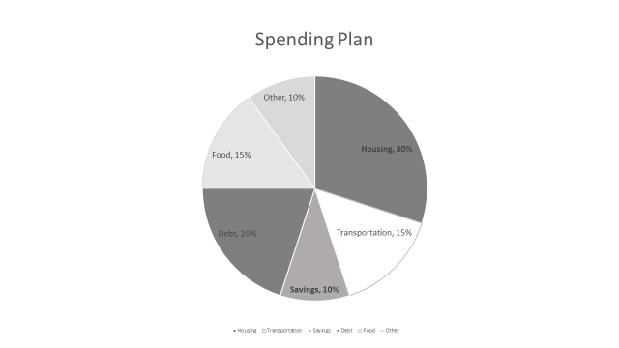

- Spending Plan (27 pts)
Category | Amount
INCOME | $
TOTAL INCOME | $
EXPENSES
RENT

UTILITIES

CAR PAYMENT

CAR INSURANCE

TRANSPORTATION (gas, oil, parking, repairs, other)

SAVINGS

FOOD

UTILITIES

CELL PHONE

BUS FARE

CLOTHING

ENTERTAINMENT

HOUSEHOLD ITEMS

PERSONAL ITEMS

OTHER

TOTAL EXPENSES (1) | $

MOVING IN COSTS
RENT FOR FIRST MONTH

RENT FOR LAST MONTH

SECURITY DEPOSIT

UTILITY DEPOSIT
MOVING IN EXPENSES (2)

COST OF FURNISHING
BEDROOM(S)

BATHROOM

LIVING ROOM

KITCHEN

OTHER

TOTAL FURNISHINGS EXPENSE (3)

- Summary: Total cost for first month (expenses 1 + 2 + 3)

$_______________________

- Choosing Housing Necessities (25 pts)
Bedroom
Bed

Dresser

Nightstand

Pillow

Sheets

Bedspread

Lamp

Other

Bathroom
Towel

Shower curtain

Rug

Toiletries

Other

Living Room
Couch

Chair

TV

Lamp

Other Electronics

Other

Dining room
Table

Chairs

Other

Kitchen
Dishes

Pots/pans

Silverware

Glasses

Cooking utensils

Dish towels

Other

Other Items
Item

Item

Item

Total Furnishings

On a separate sheet of paper answer the following:

- What advice would give to someone planning to move out on their own?

 | 5 | 4 | 3 | 2 | 1 | 0
Advice | Fully explains with supporting evidence four elements of moving out | Fully explains with supporting evidence three elements of moving out | Fully explains with supporting evidence two elements of moving out | Explained one or more pieces of advice with minor errors (1 – 2) or no supporting evidence | Explained one or more pieces of advice with major errors (1 – 2) or no supporting evidence | No attempt

- In a paragraph or two explain your experience (what did you learn) from this project and how you will plan to move out on your own.

 | 5 | 4 | 3 | 2 | 1 | 0
Experience | Fully explains with supporting evidence four things learned | Fully explains with supporting evidence three things learned | Fully explains with supporting evidence two things learned | Explained one or more things learned with minor errors (1 – 2) or no supporting evidence | Explained one or more things learned with major errors (1 – 2) or no supporting evidence | No attempt
Plan | Fully explains with supporting evidence four ways to plan for moving out | Fully explains with supporting evidence three ways to plan for moving out | Fully explains with supporting evidence two ways to plan for moving out | Explained one or more ways to plan for moving out with minor errors (1 – 2) or no supporting evidence | Explained one or more ways to plan for moving out with major errors (1 – 2) or no supporting evidence | No attempt

